|  |  |  |  |
| --- | --- | --- | --- |
| **CS102** | **Spring 2017/18** | Project Group | 2F |
| Instructor: | **David Davenport** |  |  |
| Assistant: | Sepehr Bakhshi |  |  |

|  |  |  |
| --- | --- | --- |
| **Criteria** | **TA/Grader** | **Instructor** |
| Presentation |  |  |
|  |  |  |
|  |  |  |
|  |  |  |
| Overall |  |  |

~ Bilkent Companion ~

6 Bugz

Sahra Karakoç, Elif Kurtay, Cansu Moran,

Öykü Irmak Hatipoğlu, Atakan Dönmez, Yusuf Ardahan Doğru

|  |
| --- |
| UIDesign Report  ( version 1 )  19 March 2019 |

# Introduction

University has always been one of the most dynamic environments; containing young people full of energy that actively spends their time at the campus. It is often that these students feel the need to reach out to other students, for a number of reasons. Among Bilkent students, being able to reach out to each other is a need which has already caused some of them to create bunch of groups on social media platforms including Facebook, Instagram and even Twitter. Students try to use these platforms to sell and buy things, especially books and search for their lost items/return some found objects. However, all of these entries are messily distributed on social media and lack organization which makes it harder for students to actually do what they want. Since these platforms are big, messy and therefore hard to navigate through, most of the targeted items do not reach to other students who need them. Therefore, we propose an application where Bilkent students can connect to each other through forums that are organized with sections like “Sell/Buy” or “Lost\Found”.

We will make an Android application whose target users will be Bilkent students. Further updates may be added to the application as the needs of an average Bilkent student are investigated in detail. Single phone application only for to have all the required sections in it would be a great companion on a Bilkent student daily. The application consists of many links that connect to user to the desired actions. There are 4 links on the main menu: Lost & Found, Buy/Sell, Settings, ChatRoom. In each page, there is a “back” button and a menu button. Also, there are buttons to the 4 links mentioned above.

# Details

All pages except the sign-in pages or the settings pages include 4 buttons (the ones that were in the main menu) at the bottom to help the user navigate through the app easily. The button of the page you are on is highlighted. The 4 pages also include a Back button that takes you back to the last page and a home button that takes you to the main menu.

* Sign-in page: The user enters the information to create their profile. This includes their name, surname, Bilkent webmail, password and security questions to recover password.
* Login page: After the user has been signed in, the user can enter the application through login page that asks the user for their mail address and the password that they have picked in the sign in page. There is also a forgot my password option which asks the security questions to reset password.
* Main menu: The main menu consists of 4 buttons including Buy/Sell, Lost/Found, Settings and Chatrooms.

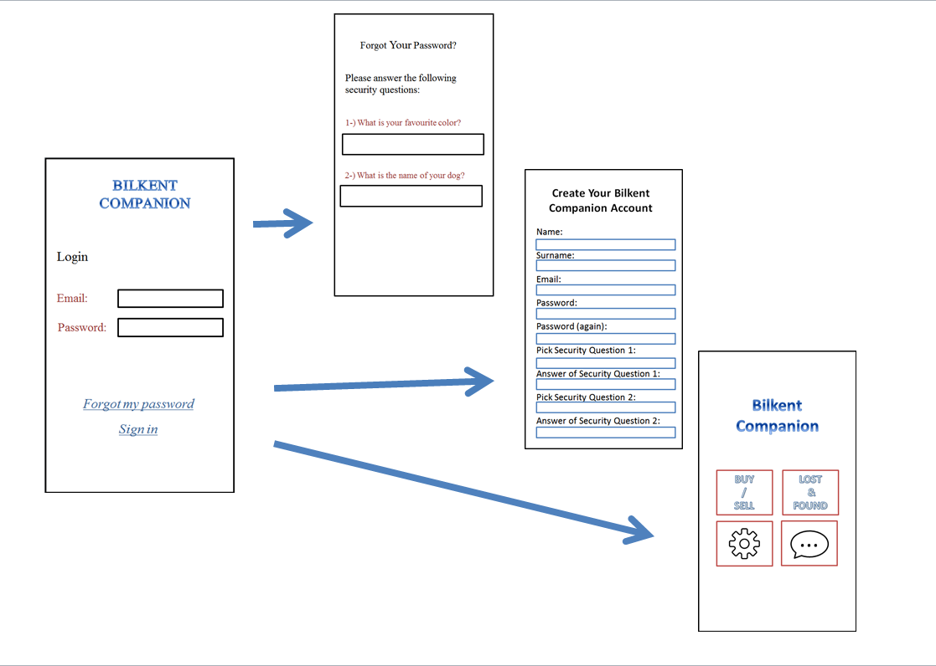

* Lost/found main page: This page includes buttons that are labeled with category names money, tech, books and other. In addition, there is an upload option to create a new entry for the objects the user has found.
  + (upload page) the upload page includes:
  + The categories to picked for the item
  + The properties of the item
  + Where the item has been found
  + The photo of the item
* Lost/found forum entries: All the found items in that category are listed in a chronological order. There is a search bar at the top of the page to make it easier to locate the item you are searching for.

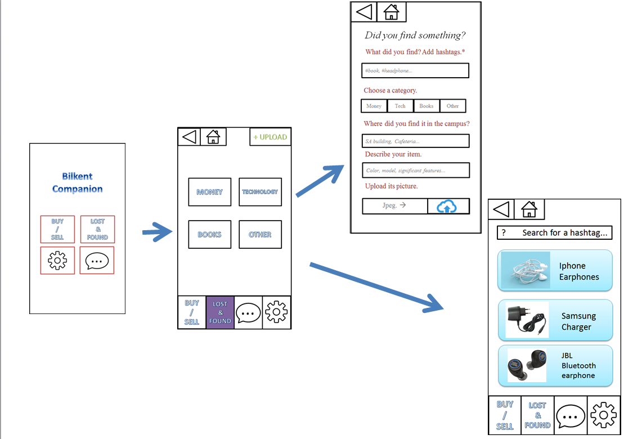

* Chatrooms: Once the user has clicked on an item that they think belongs to them, they go into a chatroom with the founder of the object to discuss the details of the object further and if it is indeed their item pick somewhere to get it. The users can access the chatroom from any page. The users’ chats are listed with options to end chat and block the user. The notifications appear next to their name.

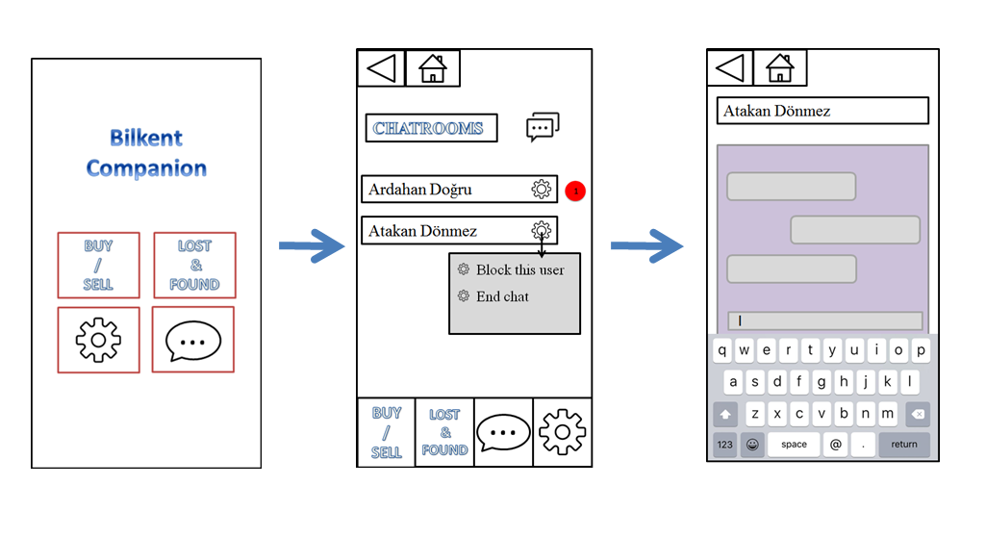

* Settings: Settings include change profile and logout otions. Also, help otion is included to give a brief explanation of the app. Change profile option has the same layout as the sign in page. Therefore the user can change anything they have entered on the sign in page later on with this option.

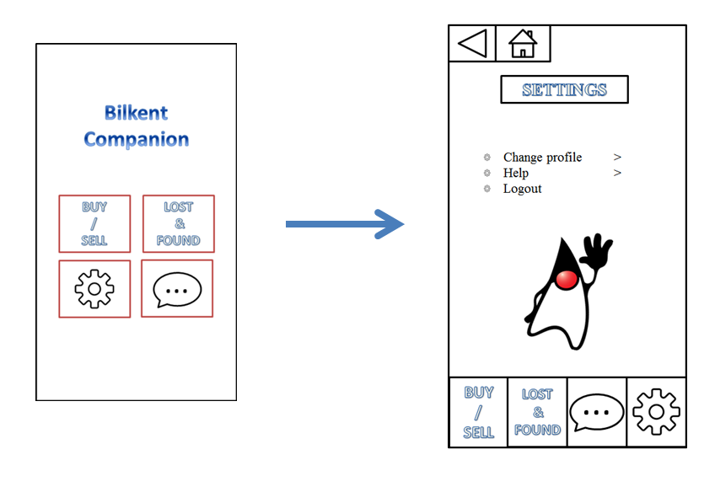

* Buy/sell: buy/sell option is the same with lost/found. Only differences are, there is money category is replaced with clothing category and the upload page includes the price of the item instead of where the item has been found in the campus.

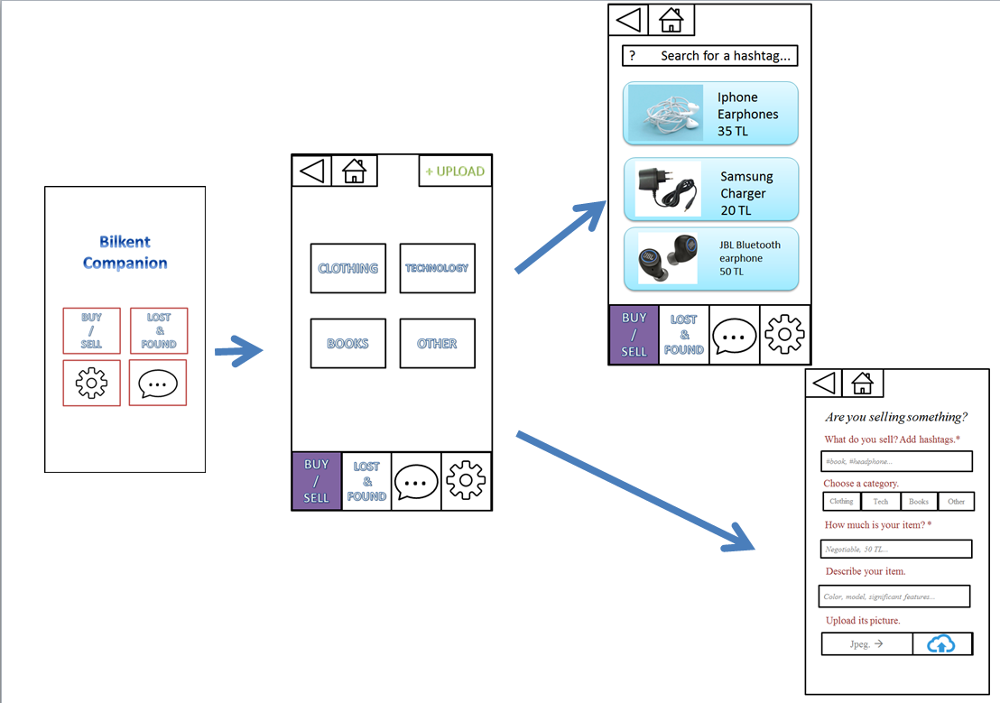

# Summary & Conclusions

This application will be the perfect tool for the student of the Bilkent University by collecting some of the needed and wanted features (Lost & Found and Buy/Sell) in one mobile phone application. Rather than searching different platforms for their needs, hopefully, student will be able to find solution to their problems much easier and faster, making them keep up with the dynamic environment of university.

There are a few projects that display various features about Bilkent like an application for showing the cafeteria menu (Bilmenu) or a website that is called IEEE Schedular which is helps students to arrange their programs. However, there isn’t an application that will manage the sell / buy and lost & found problems in bilkent by using a forum. Hence our project will be extremely helpful for the students who lost their belongings and want to sell or buy something from another student.

We designed the UI in way that it is very intuitive to the users as the lost/found and buy/sell parts have very similar structures. This allows the users to the get used to the layout of the app and they can easily navigate in the app. Also there are always indication as to where you are in the app and buttons are available on most pages to quickly and easily switch between different pages of the app.